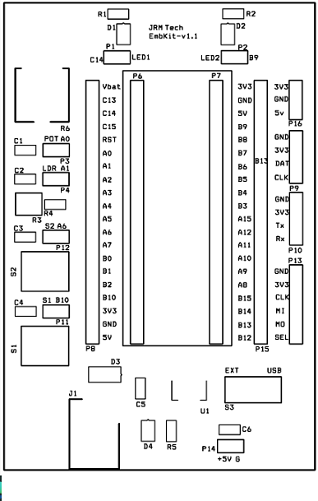
Digital output : LED 1 at PC 14 and LED 2 at PB 9
Digital Input: Switch S1 at PB10 and Switch S2 at PA6
Analog Sources : POT at PA0 and LDR at PA1
STM32 Blckpill On Board USER LED at PC13 and User KEY at PA0
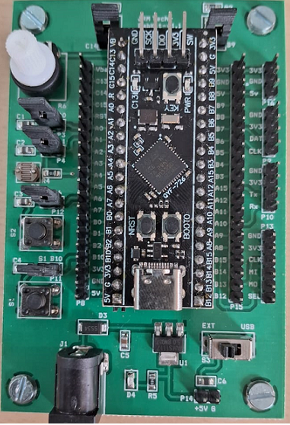
https://stm32-base.org/boards/STM32F401CEU6-WeAct-Black-Pill-V3.0

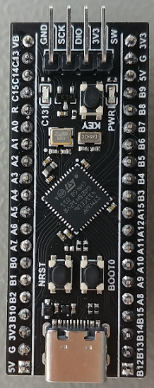
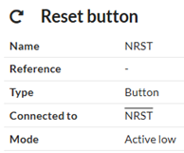
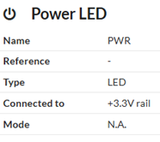
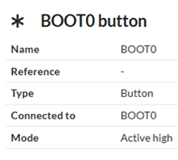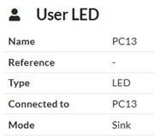
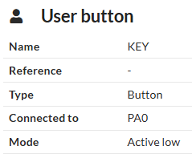
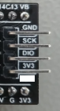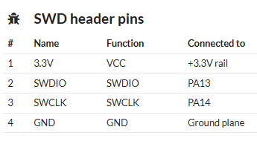

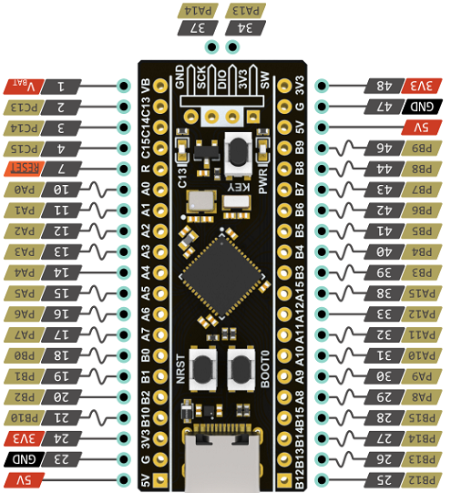
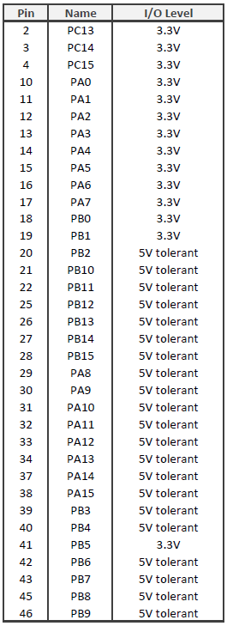

Program to blink LED at PC13 ( User LED)
#include "stm32f4xx.h"
int main(void) {
//1. Enable GPIOC clock by Writing 1 to bit2 of AHB1ENR
RCC->AHB1ENR |=(1U<<2);
//2. Set PC13 to output mode by writing 1 to bit26 of MODER
GPIOC->MODER |=(1U<<26);
while (1) {
//3. Turn off PC13 by writing 1 to bit13 of ODR
GPIOC->ODR |= (1U<<13);
//4. Delay for some time/
for(int i =0; i<180000; i++){;}
//5. Turn on PC13 by writing 0 to bit13 of ODR
GPIOC->ODR &= ~(1U<<13);
//6. Delay for some time/
for(int i =0; i<720000; i++) {}
}
}

// Program to blink LEDs at PB9 and PC14 in the Extension Board
#include "stm32f4xx.h"
int main(void) {
//1. Enable GPIOB clock by Writing 1 to bit1 of AHB1ENR
RCC->AHB1ENR |=(1U<<1);
//1. Enable GPIOC clock by Writing 1 to bit2 of AHB1ENR
RCC->AHB1ENR |=(1U<<2);
//2. Set PB9 to output mode by writing 1 to bit18 of GPIOB MODER
GPIOB->MODER |=(1U<<18);
//2. Set PC14 to output mode by writing 1 to bit28 of GPIOC MODER
GPIOC->MODER |=(1U<<28);
while (1) {
//3. Turn on PB9 by writing 1 to bit9 of GPIOB ODR
GPIOB->ODR |= (1U<<9);
//3. Turn off PC14 by writing 0 to bit14 of GPIOC ODR
GPIOC->ODR &= ~ (1U<<14);
//4. Delay for some time/
for(int i =0; i<180000; i++){;}
//3. Turn off PB9 by writing 0 to bit9 of GPIOB ODR
GPIOB->ODR &= ~(1U<<9);
//3. Turn on PC14 by writing 1 to bit14 of GPIOC ODR
GPIOC->ODR |= (1U<<14);
//6. Delay for some time/
for(int i =0; i<180000; i++) {}
}
}

// Control the status of User LED (PC13) by the User Button ( Key at PA0)
#include "stm32f4xx.h"
int main(void) {
/*1. Enable GPIOA clock by Writing 1 to bit0 of AHB1ENR*/
RCC->AHB1ENR |=(1U<<0);
/*2. Enable GPIOC clock by writing 1 to bit2 of AHB1ENR*/
RCC->AHB1ENR |=(1U<<2);
/*3. Set PA0 to input mode by writing 0 to bit0 of and bit 1 of MODER*/
GPIOA->MODER |=(0U<<0);
GPIOA->MODER |=(0U<<1);
GPIOA->PUPDR &= ~0x00000003; /* clear pull-up/pull-down bits for PA0*/
GPIOA->PUPDR |= 0x00000001; /* set pull-up for PA0 */
/*4. Set PC13 to output mode by writing 1 to bit 26 of MODER*/
GPIOC->MODER |=(1U<<26);
while (1) {
/*5. Check if input is high by checking if bit0 of port A is 1*/
if(GPIOA->IDR & (1U<<0)) {
/*6. Turn on PC13 by writing 0 to bit13 of ODR*/
GPIOC->ODR &=~(1U<<13);
}
else{
/*7. Turn off PC13 by writing 1 to bit13 of ODR */
GPIOC->ODR |=(1U<<13);
}
}
}

// Control the status of LED 1 at PC14 by Switch S1 at PB10 and status of LED 2 at PB9 by Switch S2 at PA6
// Digital output : LED 1 at PC 14 and LED 2 at PB 9
// Digital Input: Switch S1 at PB10 and Switch S2 at PA6
#include "stm32f4xx.h"
int main(void) {
/*1. Enable GPIOA clock by Writing 1 to bit0 of AHB1ENR*/
RCC->AHB1ENR |=(1U<<0);
/*2. Enable GPIOB clock by writing 1 to bit1 of AHB1ENR*/
RCC->AHB1ENR |=(1U<<1);
/*2. Enable GPIOC clock by writing 1 to bit2 of AHB1ENR*/
RCC->AHB1ENR |=(1U<<2);
/*3. Set PB10 to input mode by writing 0 to bit20 of and bit 21 of MODER*/
GPIOB->MODER |=(0U<<20);
GPIOB->MODER |=(0U<<21);
GPIOB->PUPDR &= ~0x00300000; /* clear pull-up/pull-down bits for PB10*/
GPIOB->PUPDR |= 0x00100000; /* set pull-up for PB10 */
[/*3. Set PA6 to input mode by writing 0 to bit12 of and bit 13 of MODER*/
GPIOA->MODER |=(0U<<12);
GPIOA->MODER |=(0U<<13);
GPIOA->PUPDR &= ~0x00003000; /* clear pull-up/pull-down bits for PA6*/
GPIOA->PUPDR |= 0x00001000; /* set pull-up for PA6 */
///////////////////////////
/*4. Set PC14 to output mode by writing 1 to bit 28 of MODER*/
GPIOC->MODER |=(1U<<28);
/*4. Set PB9 to output mode by writing 1 to bit 18 of MODER*/
GPIOB->MODER |=(1U<<18);

while (1) {
/*5. Check if input S1 at PB10 is high by checking if bit10 of port B is 1*/
if(GPIOB->IDR & (1U<<10)) {
/*6. Turn off LED1 at PC14 by writing 0 to bit14 of ODR*/
GPIOC->ODR &=~(1U<<14);
}
else{
/*7. Turn on LED1 at PC14 by writing 1 to bit14 of ODR */
GPIOC->ODR |=(1U<<14);
}

///////////////////////
/*5. Check if input S2 (PA6) is high by checking if bit6 of port A is 1*/
if(GPIOA->IDR & (1U<<6)) {
/*6. Turn off LED2 at PB9 by writing 0 to bit9 of ODR*/
GPIOB->ODR &=~(1U<<9);
}
else{
/*7. Turn on LED2 at PB9 by writing 1 to bit9 of ODR */
GPIOB->ODR |=(1U<<9);
}

}
}

